**OUTPUT**

**GET:** [**http://localhost:5001/**](http://localhost:5001/)

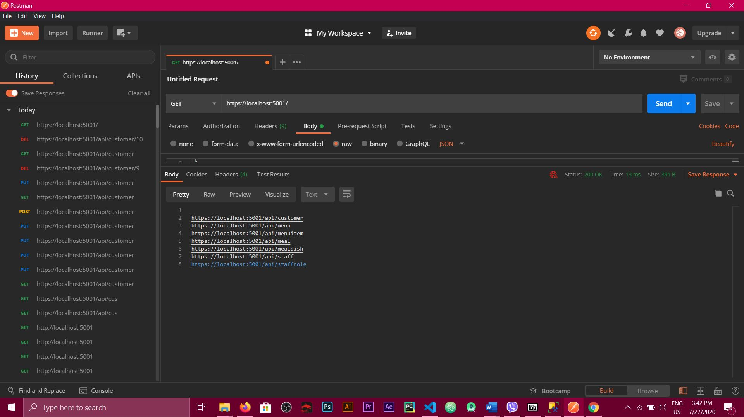

**GET:** [**http://localhost:5001/api/customer/**](http://localhost:5001/api/customer/)

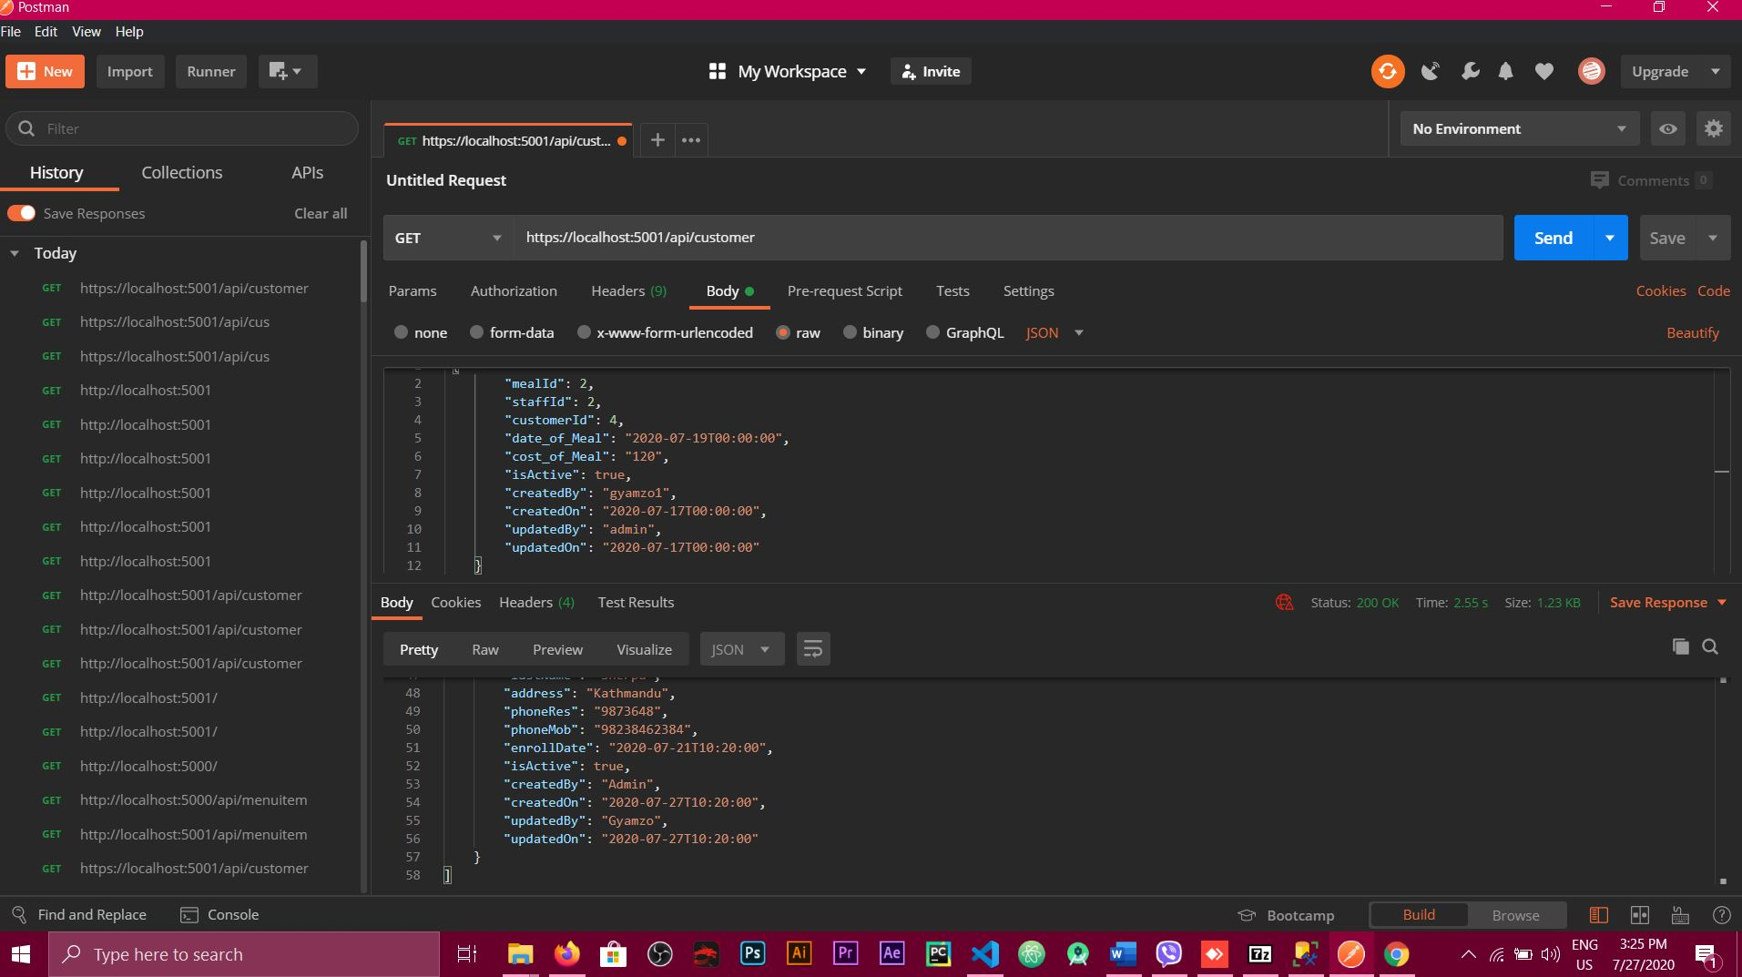

**POST:** [**http://localhost:5001/api/customer**](http://localhost:5001/api/customer)

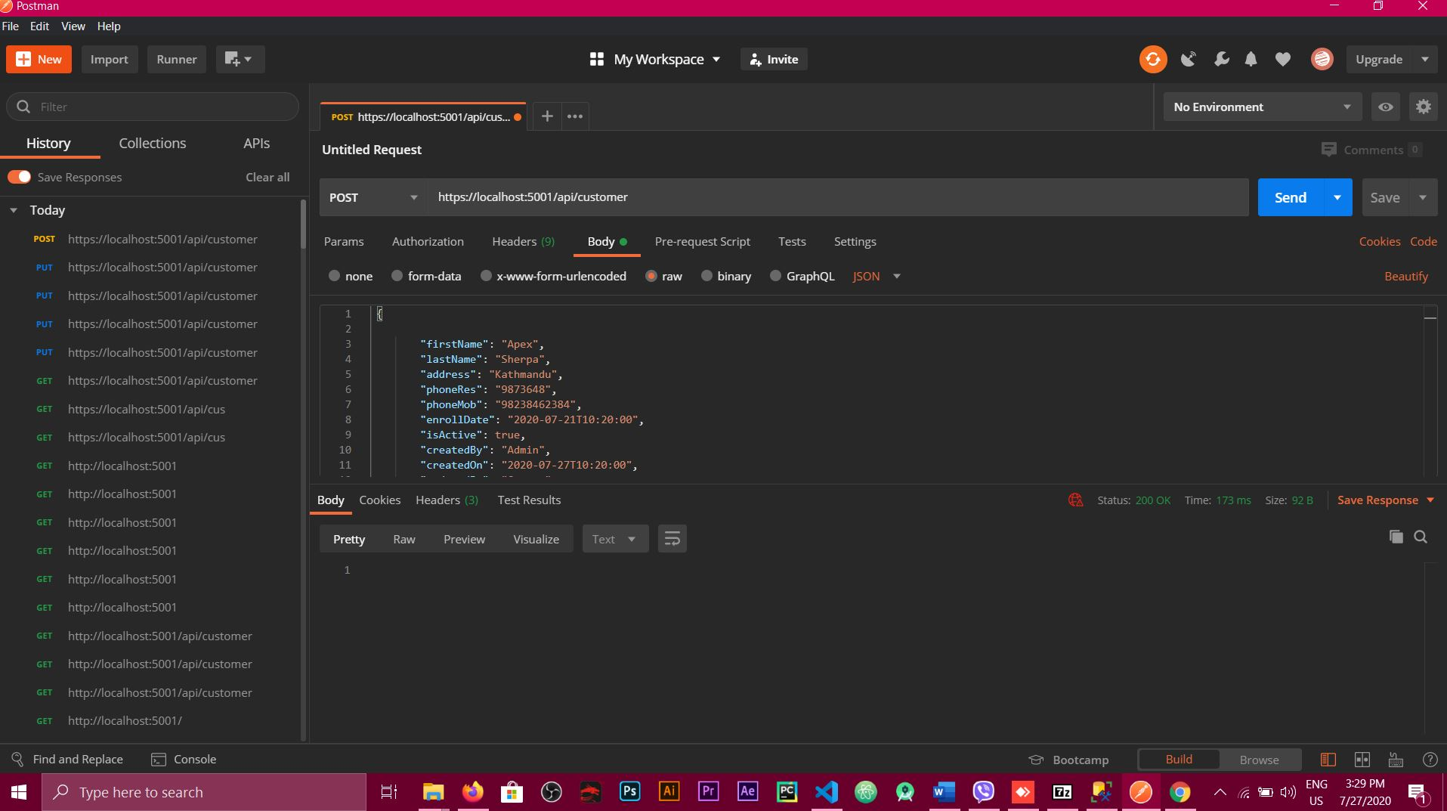

**PUT:** <http://localhost:5001/api/customer>

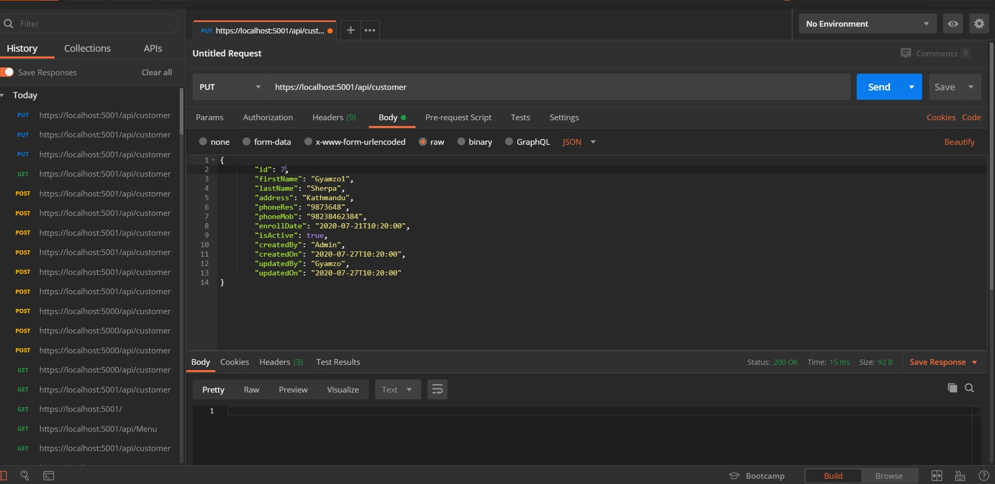

**GET:** <http://localhost:5001/api/meal>

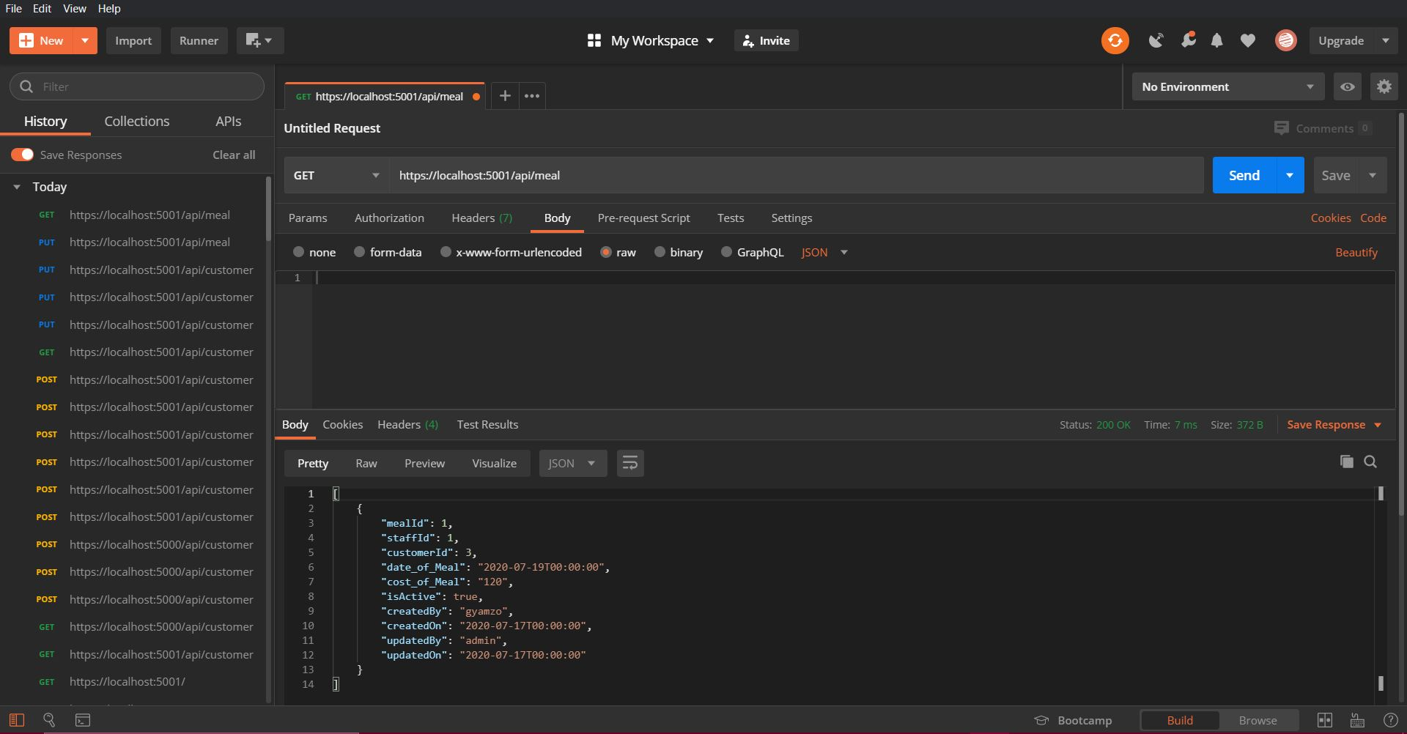

**GET:** [**http://localhost:5001/api/**](http://localhost:5001/api/)[mealdish](http://localhost:5000/api/mealdish)

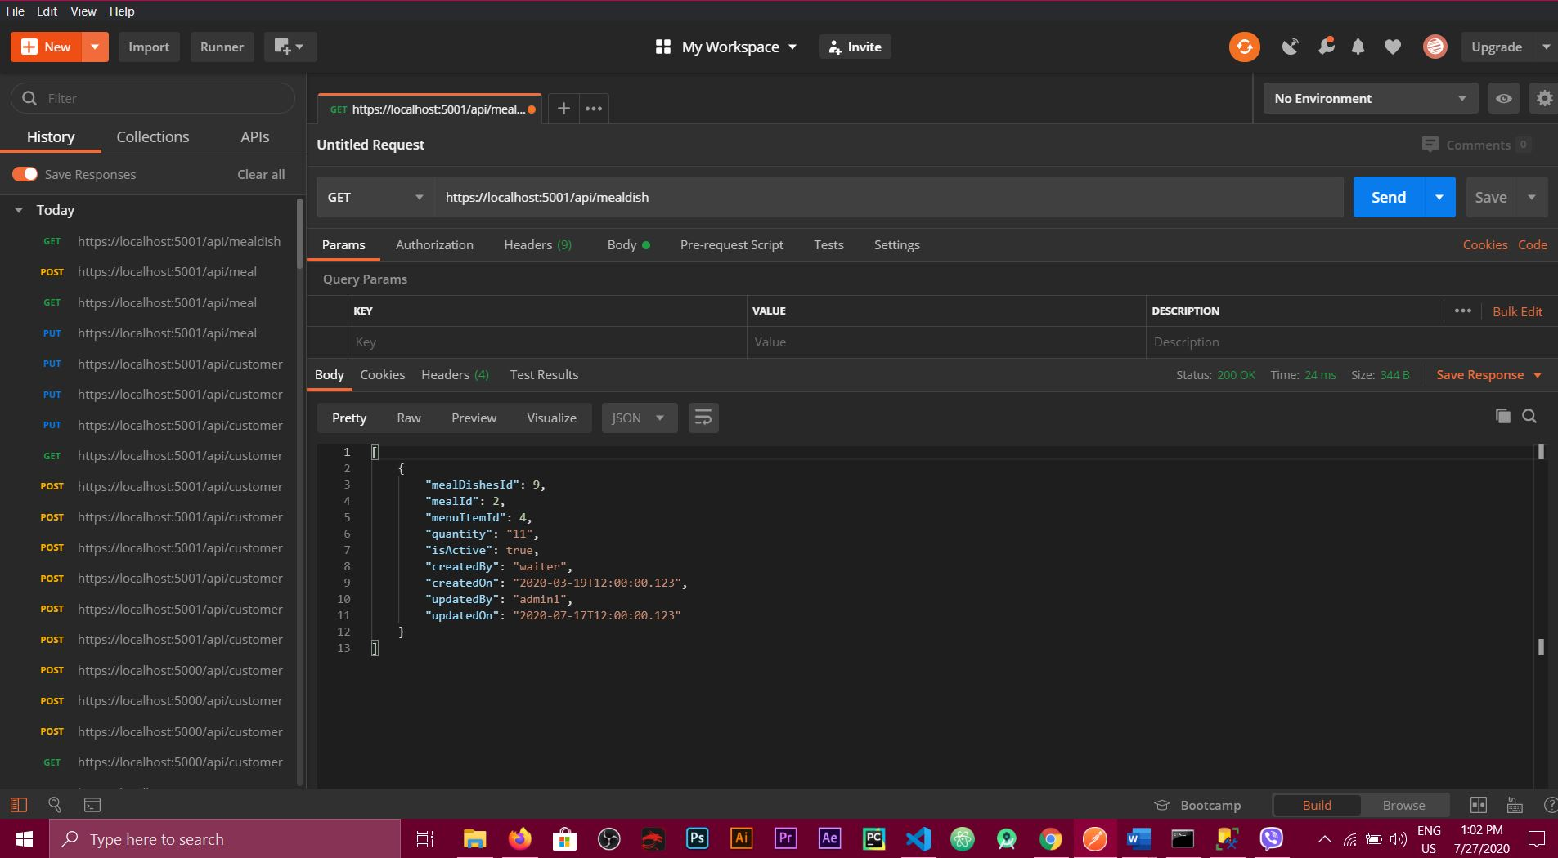

**GET:** [**http://localhost:5001/api/**](http://localhost:5001/api/)[**staff**](http://localhost:5000/api/staff)

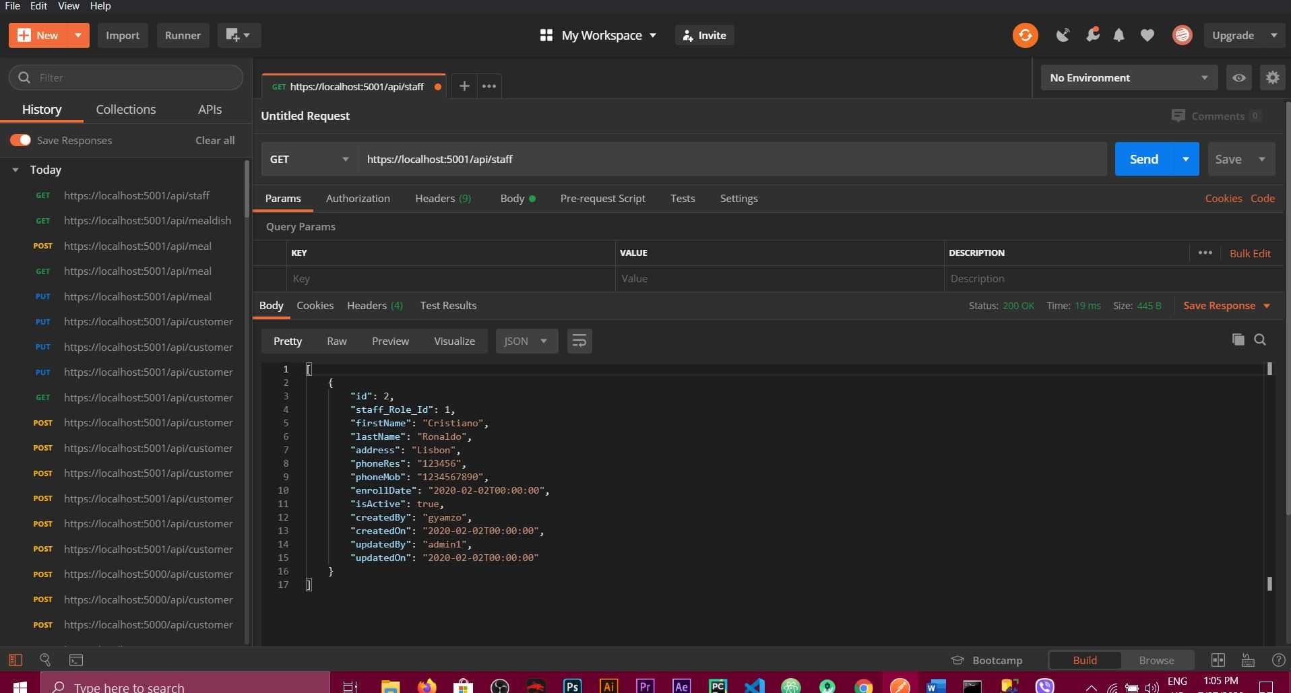

**GET:** [**http://localhost:5001/api/**](http://localhost:5001/api/)[**staffrole**](http://localhost:5000/api/staffrole)

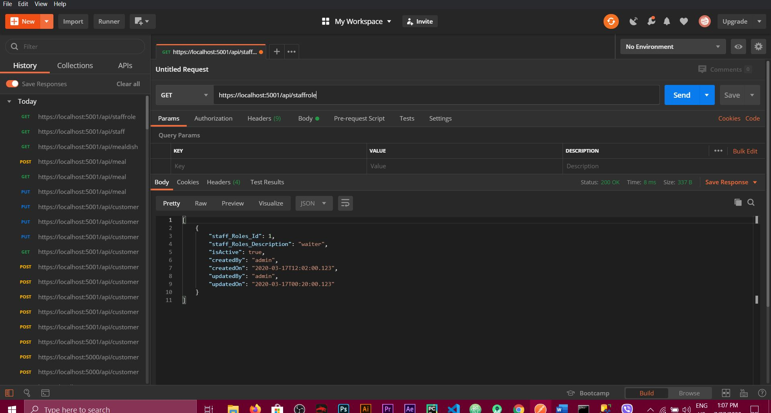

**GET:** [**http://localhost:5001/api/**](http://localhost:5001/api/)[**menu**](http://localhost:5000/api/menu)

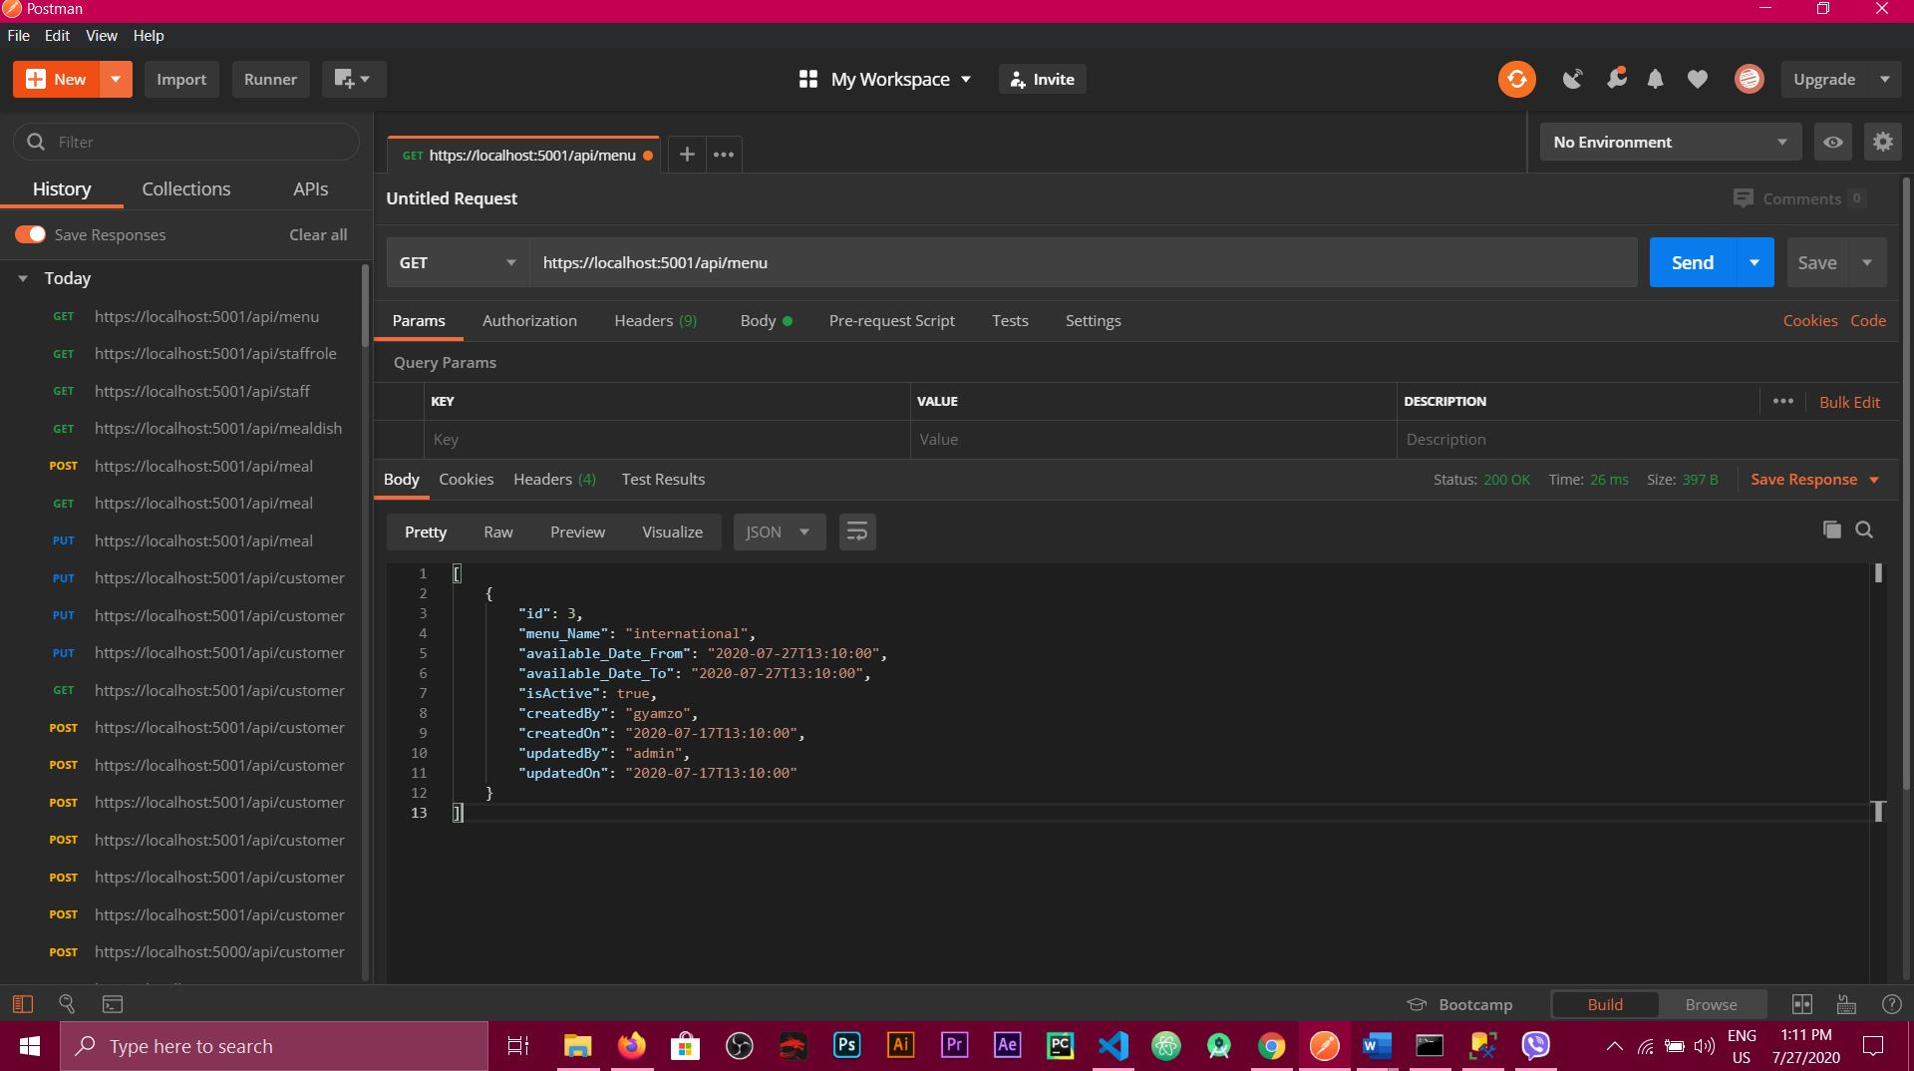

**GET:** [**http://localhost:5001/api/**](http://localhost:5001/api/)[**menuitem**](http://localhost:5000/api/menuitem)

